City Safety Control Function – CGEA1.3

Functional Description

The City Safety Control Functions informs the user about the activity or malfunction of the Low Speed Collision Mitigation by Braking (LSCMbB) feature. The Low Speed Safety System feature can be turned on/off via Message Center. At start-up the default shall be 'ON'. Warning message will inform the driver of any faults in the system.

The City Safety Control Functions correlates the Ignition_Status signal, the LscmbbMntr_B_Err signal, the LscmbbBlck_B_Actl signal, the LscmbbMsgTxt_D_Rq signal, the LscmbbPostEvnt_B_Dsply signal, the LscmbbSrvcRqd_B_Rq signal, the vehicle configuration, and the Operational_Mode to display various warnings. The Message Center provides a menu to turn the City Safety feature on/off. The City Safety Control Function uses signal LscmbbStat_B_Actl to command the system on/off.

Interfaces

Interface Context Diagram (I/O Block Diagram)

City Safety Control Function Context Diagram
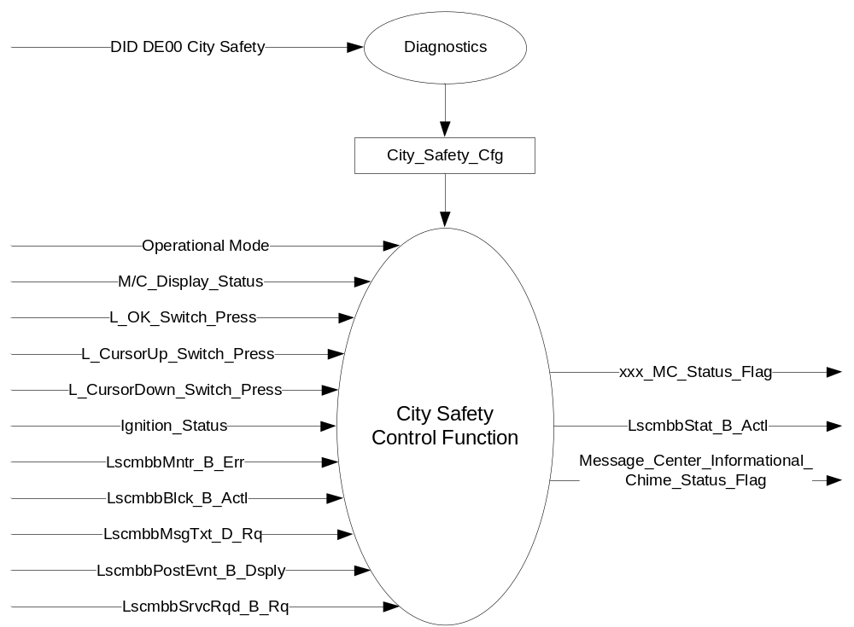

Inputs

      - Operational_Mode
      - M/C_Display_Status
      - L_OK_Switch_Press
      - L_CursorUp_Switch_Press
      - L_CursorDown_Switch_Press
      - City_Safety_Cfg
      - CAN Signals

- Ignition_Status Signal
Signal Name | Size  (bits) | Detail | Units | Res. | Offset | State  Encoded | Min | Max
Ignition_Status | 4 |  | SED | 1 | 0 |  | 0 (0x0) | 15 (0xF)
 |  | Unknown |  |  |  | 0x0
 |  | Off |  |  |  | 0x1
 |  | Accessory |  |  |  | 0x2
 |  | Run |  |  |  | 0x4
 |  | Start |  |  |  | 0x8
 |  | Invalid |  |  |  | 0xF

- LscmbbMntr_B_Err Signal
Signal Name | Size  (bits) | Detail | Units | Res. | Offset | State  Encoded | Min | Max
LscmbbMntr_B_Err | 1 |  | SED | 1 | 0 |  | 0  (0x0) | 1  (0x1)
 |  | NoMessage |  |  |  | 0 (0x0)
 |  | DisplayMessage |  |  |  | 1 (0x1)

- LscmbbBlck_B_Actl Signal
Signal Name | Size  (bits) | Detail | Units | Res. | Offset | State  Encoded | Min | Max
LscmbbBlck_B_Actl | 1 |  | SED | 1 | 0 |  | 0  (0x0) | 1  (0x1)
 |  | No |  |  |  | 0 (0x0)
 |  | Yes |  |  |  | 1 (0x1)

- LscmbbMsgTxt_D_Rq Signal
Signal Name | Size  (bits) | Detail | Units | Res. | Offset | State  Encoded | Min | Max
LscmbbMsgTxt_D_Rq | 1 |  | SED | 1 | 0 |  | 0  (0x0) | 1  (0x1)
 |  | No |  |  |  | 0 (0x0)
 |  | Yes |  |  |  | 1 (0x1)

- LscmbbPostEvnt_B_Dsply Signal
Signal Name | Size  (bits) | Detail | Units | Res. | Offset | State  Encoded | Min | Max
LscmbbPostEvnt_B_Dsply | 1 |  | SED | 1 | 0 |  | 0  (0x0) | 1  (0x1)
 |  | No |  |  |  | 0 (0x0)
 |  | Yes |  |  |  | 1 (0x1)

- LscmbbSrvcRqd_B_Rq Signal
Signal Name | Size  (bits) | Detail | Units | Res. | Offset | State  Encoded | Min | Max
LscmbbSrvcRqd_B_Rq | 1 |  | SED | 1 | 0 |  | 0  (0x0) | 1  (0x1)
 |  | No |  |  |  | 0 (0x0)
 |  | Yes |  |  |  | 1 (0x1)

Outputs
- xxx_MC_Status_Flag
- Message_Center_Informational_Chime_Status_Flag
- CAN Signal

- LscmbbStat_B_Actl Signal
Signal Name | Size  (bits) | Detail | Units | Res. | Offset | State  Encoded | Min | Max
LscmbbStat_B_Actl | 1 |  | SED | 1 | 0 |  | 0  (0x0) | 1  (0x1)
 |  | Off |  |  |  | 0 (0x0)
 |  | On |  |  |  | 1 (0x1)

Function/Performance

Operational Modes

Mode | Differentiating Vehicle Conditions
Sleep Mode | OFF
Limited Mode | OFF
Normal Mode | City Safety ON / OFF
Crank Mode | City Safety ON / OFF

Voltage Levels

Refer to the Cluster Features Table located in the Operational Modes and Voltage Range Strategies of this SPSS.

Human-Machine Interface

Visual

Indicator Graphics / Display Format
For High End Display (SHMI), reference HMI Specifications:
Text: Program Master Warning Message List.xls | Program Translation Table.xls
Structure: Program Menu Structure.xls
Control Logic: Program HMIDialog_Diagram.pdf

Reference the following Message IDs in the Text Message List file for the appropriate display: W1710, W1711, and W1712.

Menu Structure:

LEVEL 3 | LEVEL 4 | Confirmation Text
City Safety > | ☑ ON  ◻ OFF | City Safety Set to ON  City Safety Set to OFF

MENU
> = Submenu
# = Check box (on/off)
* = Radio button (1 from n)
~ = Overlay function

Indicator Color Coordinates

Reference section COLOR & ILLUMINATION REQUIREMENTS (GRAPHICS)

Indicator Characteristics

Refer to Message Center X Display_Y Button Interface Section, where X and Y are appropriate values in this document.

Audio

Message_Center_Informational_Chime_Status_Flag
Reference Table 1.11 for chimes associated with warning messages within this STSS.

Switch Control Logic

Consumer access to the City Safety Control Configuration shall be as specified in the Message Center_SHMI Displays_5 Button Interface (STSS).

System Accuracy

Within a 100msec of receiving a message that results in a change of state the cluster will update the display to the proper status.

Operation: Performance and Functional

Subsystem Algorithm Flowchart / State Diagram

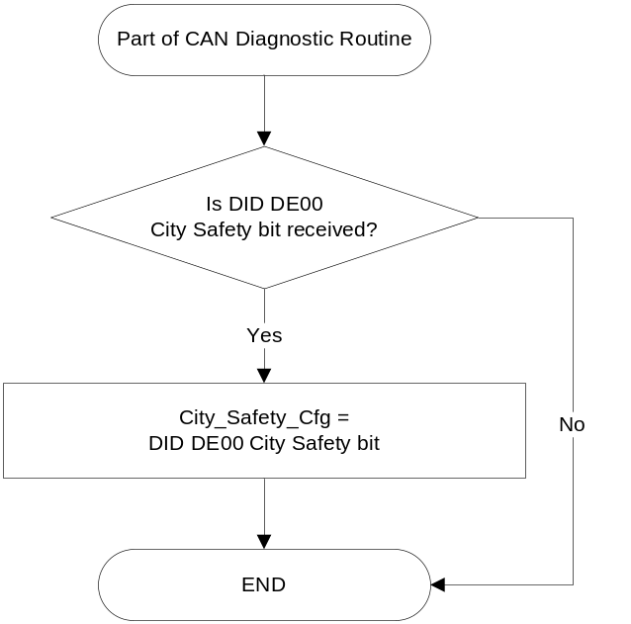

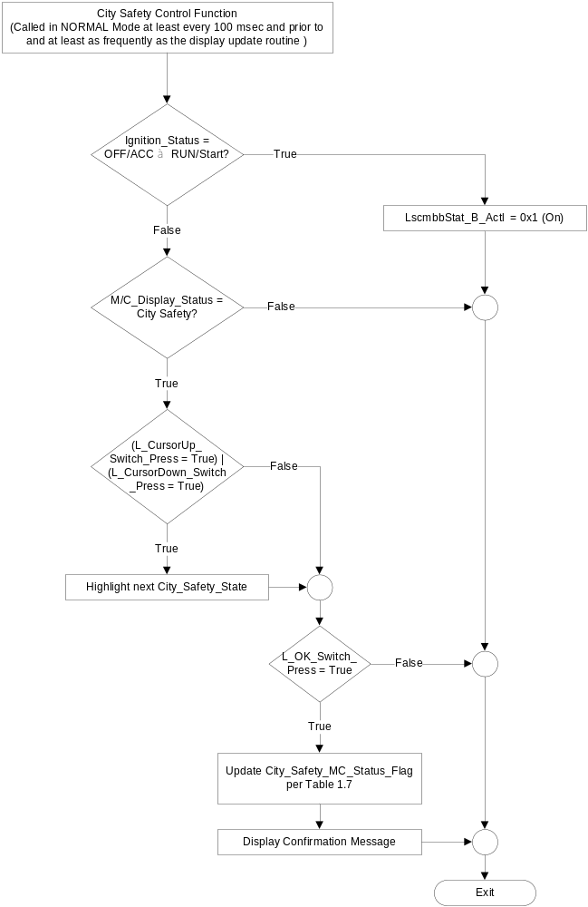

- Next City_Safety_ MC_Status_Flag
City_Safety_ MC_Status_Flag | Current City_Safety_Display | 5-Button Switch  Selection Event | Next City_Safety_MC  _Status_Flag | Confirmation Text for Temporary Pop-Up | LscmbbStat_B_Actl Signal
True | ☑ ON (0x1)  ◻ OFF (0x0) | Up/Down + OK  (Select OFF) | False | City Safety  Set to OFF | 0x0 (Off)
False | ◻ ON (0x1)  ☑ OFF (0x0) | Up/Down + OK  (Select ON) | True | City Safety  Set to ON | 0x1 (On)

- Lscmbb_NA_MC_Status_Flag based on Inputs
Operational  _Mode | City_Safety_Cfg | LscmbbSrvcRqd  _B_Rq | LscmbbMsgTxt  _D_Rq | LscmbbMntr_B_Err | Lscmbb_NA_MC_  Status_Flag
Normal  or Crank | Enabled | 0x1 (Yes) | X | X | 0x1 (Active)
Normal  or Crank | Enabled | X | 0x1 (Yes) | X | 0x1 (Active)
Normal  or Crank | Enabled | X | X | 0x1 (DisplayMessage) | 0x1 (Active)
Normal  or Crank | Enabled | Missing per 1.4.1 | X | X | 0x1 (Active)
All Other Cases |  |  |  |  | 0x0 (Inactive)
Note: Since CAN signals LscmbbSrvcRqd_B_Rq, LscmbbMsgTxt_D_Rq, LscmbbBlck_B_Actl, and LscmbbPostEvnt_B_Dsply and all in the same CAN message, only one signal need be used to trigger the missing message strategy for the Front Distance Range Sensor. When the message is missing, W1712 will be Active. Missing message for LscmbbMntr_B_Err will be handled in the ABS Telltale spec.

- Lscmbb_Blck_MC_Status_Flag based on Inputs
Operational  _Mode | City_Safety_Cfg | LscmbbBlck_B_Actl | Lscmbb_Blck _MC_Status_Flag
Normal  or Crank | Enabled | 0x1 (Yes) | 0x1 (Active)
All Other Cases |  |  | 0x0 (Inactive)

- Lscmbb_Brk_MC_Status_Flag based on Inputs
Operational  _Mode | City_Safety_Cfg | LscmbbPostEvnt_B_Dsply | Lscmbb_Auto_Brk_MC_Status_Flag
Normal  or Crank | Enabled | 0x1 (Yes) | 0x1 (Active)
All Other Cases |  |  | 0x0 (Inactive)

- MC_Status_Flag to MC Warning Message ID
Active MC_Status_Flag | MC Warning Message ID | Active CHIME_STATUS_FLAG
Lscmbb_Auto_Brk_MC_Status_Flag | W1710 | None
Lscmbb_Blck_MC_Status_Flag | W1711 | Message_Center_Informational_Chime_Status_Flag
Lscmbb_NA_MC_Status_Flag | W1712 | Message_Center_Informational_Chime_Status_Flag

Operation Description (supports algorithm flowchart /state diagram)

The City Safety Control Function allows the driver to turn the City Safety feature On/Off through the message center. When in the City Safety Setup page, an Up or Down message center button press will highlight the next Menu Setup selection. An OK message center button press while on this page will set the City_Safety_MC_Status_Flag and signal LscmbbStat_B_Actl to the highlighted selection and a confirmation message will be displayed.

When Lscmbb_Auto_Brk_MC_Status_Flag is active, Warning message W1710 will be displayed. When Lscmbb_Blck_MC_Status_Flag is active, Warning message W1711 will be displayed. When Lscmbb_NA_MC_Status_Flag is active, Warning message W1712 will be displayed.

Function Safety Classification (EMC)

B

Memory Storage

Parameter Name | Description | Value at Battery connect | Value at  Module Wake-up | Value at  OFF/Acc to Run/Start
M/C_Display_Status | Input to this routine that is a State Indicator to identify which text is currently being displayed on Message Center display. | See Message Center_SHMI Displays_5 Button Interface STSS | See Message Center_SHMI Displays_5 Button Interface STSS | See Message Center_SHMI Displays_5 Button Interface STSS
Operational_Mode | Input to this routine that is a 4 State indicator for cluster operational mode | As per Operational Modes and Voltage Range Strategies Section (STSS) | As per Operational Modes and Voltage Range Strategies Section (STSS) | As per Operational Modes and Voltage Range Strategies Section (STSS)
L_OK_Switch_Press | Reference Message Center Switch - 5 Button HSCAN Interface STSS | See Message Center Switch - 5 Button HSCAN Interface STSS | See Message Center Switch - 5 Button HSCAN Interface STSS | See Message Center Switch - 5 Button HSCAN Interface STSS
L_CursorUp_Switch_Press | Reference Message Center Switch - 5 Button HSCAN Interface STSS | See Message Center Switch - 5 Button HSCAN Interface STSS | See Message Center Switch - 5 Button HSCAN Interface STSS | See Message Center Switch - 5 Button HSCAN Interface STSS
L_CursorDown_Switch_Press | Reference Message Center Switch - 5 Button HSCAN Interface STSS | See Message Center Switch - 5 Button HSCAN Interface STSS | See Message Center Switch - 5 Button HSCAN Interface STSS | See Message Center Switch - 5 Button HSCAN Interface STSS
City_Safety_Cfg | State Indicator for feature presence controlled via CAN at EOL at VO plant. Defaulted to Disabled at supplier manufacturing | Use Stored Value | Use Stored Value | Use Stored Value
Lscmbb_Auto_Brk_MC_Status_Flag | State variable used by M/C Warning Arbitrator | Inactive | Inactive | Inactive
Lscmbb_Blck_MC_Status_Flag | State variable used by M/C Warning Arbitrator | Inactive | Inactive | Inactive
Lscmbb_NA_MC_Status_Flag | State variable used by M/C Warning Arbitrator | Inactive | Inactive | Inactive
City_Safety_MC_Status_Flag | State variable used to indicate the state of the City Safety system | True | True | True
LscmbbStat_B_Actl | CAN signal | 0x1 (On) | 0x1 (On) | 0x1 (On)
LscmbbMntr_B_Err | CAN signal | 0x0 (NoMessage) | 0x0 (NoMessage) | 0x0 (NoMessage)
LscmbbBlck_B_Actl | CAN signal | 0x0 (No) | 0x0 (No) | 0x0 (No)
LscmbbMsgTxt_D_Rq | CAN signal | 0x0 (No) | 0x0 (No) | 0x0 (No)
LscmbbPostEvnt_B_Dsply | CAN signal | 0x0 (No) | 0x0 (No) | 0x0 (No)
LscmbbSrvcRqd_B_Rq | CAN signal | 0x0 (No) | 0x0 (No) | 0x0 (No)
Message_Center_Informational_Chime_Status_Flag | Used to control the state of the chime to the Chime arbitrator | Inactive | Inactive | Inactive

Prove Out

No

Reconfigurable Telltale

No

Message Center Msg

Reference displays in section 1.3.5.1.

Error Handling

Missing Message Strategy

The signals will be declared missing as per the Diagnostics section of this SPSS.

DTCs states and history will be determined as per the Diagnostics section of this SPSS.

If City_Safety_Cfg is Disabled, DTC's shall never be logged for this feature.

Diagnostics

Self Test

None

Engineering Test Mode

None

Part II Performance

Supported Diagnostic Trouble Codes (DTCs)

DTC | Description
C43382 | Invalid Data from Front Distance Range Sensor

DID DExx
Block  Num | Block Description | Byte(s) | Bits | State: Description | "0" | "1" | Default | Comments/ Information
PACKETED BLOCKS
$xx | Option Content (B&A) | * | * | City Safety | Disable | Enable | Disable | FoE Feature

Reference Specification

Revision History

SPSS Module Revision History
Revision Level | Name | Change Description | Date
1.0 | J. Gregoire | Initial Release | 12/08/2010
1.1 | J. Gregoire | Section 1.1 – corrected output signal to LscmbbStat_B_Actl  Section 1.2.1 – corrected output signal to LscmbbStat_B_Actl in the context diagram.  Table 1.6 – corrected output signal to LscmbbStat_B_Actl  Section 1.3.5.1 – corrected output signal to LscmbbStat_B_Actl in the City Safety Control Function flow chart.  Table 1.7 – corrected output signal to LscmbbStat_B_Actl  Section 1.3.5.2 – corrected output signal to LscmbbStat_B_Actl  Section 1.3.5.4 – corrected output signal to LscmbbStat_B_Actl, added other CAN signals. | 3/10/2011
1.2 | J. Gregoire | Add DTC for missing message from  Table 1.8 – Added Missing Message condition. Added note below table.  Section 1.5.3 – Added DTC C23500. | 11/26/2012
1.3 | Ilopezla | This Update is to inform which Chime Status Flag is associated with this warning  Section 1.2.1- City Safety Control Function Context Diagram  -Added Message_Center_Informational_Chime_Status_Flag  Section 1.2.3-Added Message_Center_Informational_Chime_Status_Flag  Section 1.3.3.3- Added Message_Center_Informational_Chime_Status_Flag  Section 1.3.5.4- Added Message_Center_Informational_Chime_Status_Flag as a parameter | 11/30/2016

